**Module-4**

***Individual case safety reports (ICSRs):***

Adverse drug reactions are collected in the form of Individual case safety reports (ICSRs).

Adverse event which occurs due to medicinal plant to a patient at single point of time collected as ICSR.

When do you call an ICSR a valid ICSR:

It should have at least four minimum criteria to say its valid ICSR.

1. One identifiable reporter
2. One single identifiable patient
3. At least one suspect adverse reaction
4. At least one suspect medicinal product

Example: A pharmacist called a pharmaceutical company customer care number stating that a patient received cetirizine tablet for flu and after few hours the patient experience little drowsiness.

In this scenario:

1. Who is the reporter?

Ans. Pharmacist

1. Does the case have patient

Ans. Yes

1. Adverse drug reaction?

Ans. Drowsiness

1. Medicinal product?

Ans. Cetirizine.

**Collection of Individual case safety reports:**

Competent authorities and Marketing authorization holders will collect and collate the suspected adverse drug reactions associated with the medicinal product originating from different sources.

**Various sources of ICSRs:**

|  |
| --- |
| **sources of ICSRs** |

|  |  |  |
| --- | --- | --- |
| **Unsolicited reports** |  | **Solicited reports** |

|  |  |  |
| --- | --- | --- |
| 1. Spontaneous reports 2. Literature reports 3. Reports from Non-medical sources 4. Reports from Internet & Digital media |  | 1. Clinical trials 2. Non-interventional studies 3. Registries 4. Patient use programmes 5. Disease management programmes |

There are two things to remember:

1. One is Marketing authorization Holder (MAH) that is Pharmaceutical company.
2. Second is competent authority.

MAH will collect all the spontaneous reports form various sources and submits the cases in a specified timeline to the authorities.

To submit to authorities, the report to be valid.

Sources of Individual case reports:

1. Spontaneous reports:

Spontaneous reports are unsolicited reports reported by:

1. Health care professional
2. Consumer
3. Pharmacist
4. Nurse
5. Dentist

* These reports are also called as “voluntary, unsolicited or anecdotal reports.
* The reports to be confirmed medically to be a valid report, but there is debate that consumers or patient direct reports are also potentially valuable.
* Only 2 regulatory authorities of two countries accepts the reports form consumers- USA & Canada.

1. Literature reports:
2. These reports are the significant source of information for monitoring of the adverse events or safety profile of the drug.
3. The literature is reviewed through

* Medline,
* Excerpta Medica or Embase
* PubMed

1. Reports from Non-medical sources:

Reports arising form non-medical source also considered as spontaneous reports.

Example: Press or other media

1. Reports from Digital media:
2. Web page
3. Blog
4. Internet forum
5. Health portal

Solicited reports:

The reports are considered solicited when the reports are collected from:

1. Clinical trials.
2. Noninterventional studies
3. Patient registries
4. Patient use programme

These solicited reports are considered as study reports.

Special situation:

There are some scenarios which are considered as special situations. Those are:

* Pregnancy
* Breast feeding
* Use of a medicinal product in pediatric population
* Use of a medicinal product in elderly population
* Lack of efficacy
* Reports of:

1. Misuse
2. Medication error
3. Occupational exposure
4. Overdose
5. Abuse

Note: Lack of therapeutic effect (LOE) is not reported if not associated with an adverse event. In some instances, the report becomes reportable if the drug used in critical conditions or for the treatment of life-threatening diseases, vaccines, contraceptives are few examples. This is acceptable if the reporter explains that the outcome is due to drug and not the progression of the disease.

Timelines to submission of ICSRs:

To submit a ICSR form MAH to competent authority it should be valid and two terminologies to be known

1. What is Day 0 or when the clock starts:

As soon as the complete information regarding the case is received that is a complete valid case that day is considered as “Day 0”.

For literature cases “Day 0” is the day with awareness of a publication containing the minimum criteria.

1. Why do Day 0 require:

Cases are considered as:

* Serious
* non-serious

Criteria to be consider a case as serious is based on the WHO Criteria and will be explained in the next module.

Serious cases are to be submitted in 15 calendar days to the competent authorities by MAH.

Non-serious cases are submitted within 90 calendar days to the competent authorities

LOE cases as explained before associated with adverse event and life-threatening are submitted within 15 calendar days timelines.

The seriousness of a case is decided based on the WHO criteria and will be explained in the next module.

**One more terminology required is: “International Birth Date (IBD)”**

The day when the product gets first marketing authorization containing the active substance to any company in any country in the world.

How do you submit the cases or reports to authorities:

MAH will have a database to upload the cases for example: Argus, skeptra.

After the completion of case in the database, the report will be submitted to the authority.

The submission formats and database explanation is beyond this module and will be explained in advanced course.

**Case processing:**

ICSR is a standard format for the capture of information needed to support the reporting of adverse events, product problems or consumer complaints associated with the use of medicinal product.

The various steps in case processing:

The steps in case processing various from organization to organization.

FDA & WHO drug reporting:

WHO (World Health Organization):

Adverse drug reaction form is used to report the reactions.

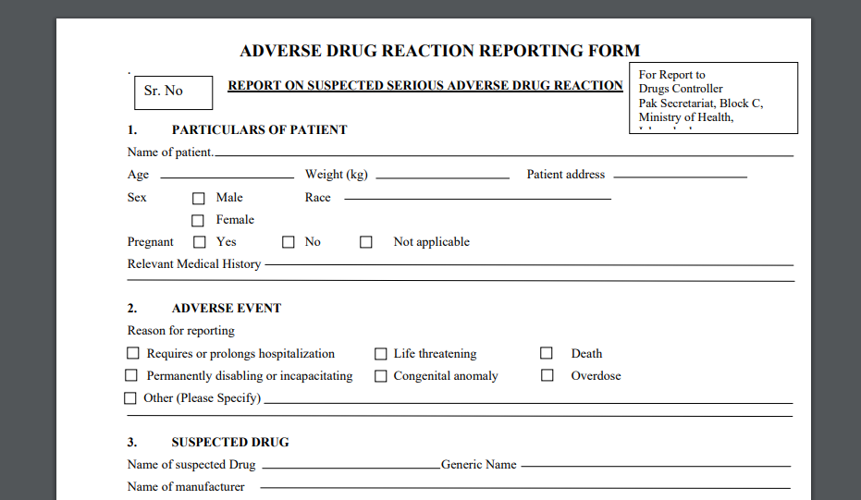

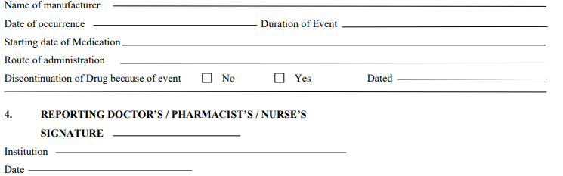

FDA reporting form is called as MEDWATCH:

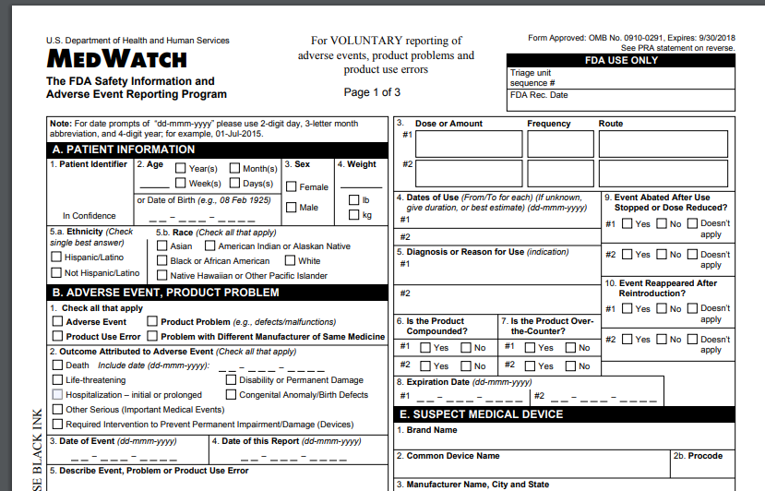

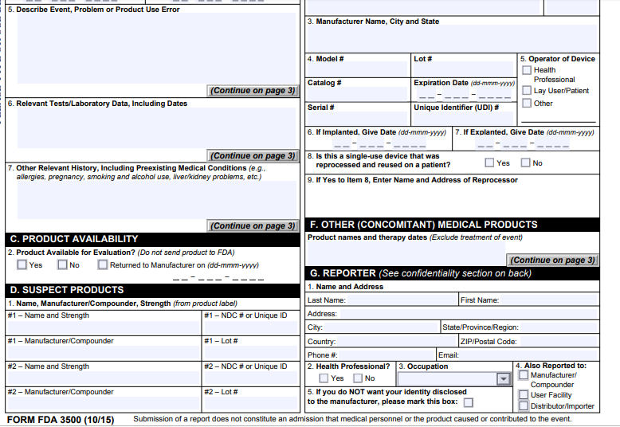

These are the forms to be filled for the reporting adverse events.

To explain the details of the each section is beyond this module.

